# Section 17: The Twentieth Vassa (Age 54-55)

According to tradition, after spending the nineteenth vassa at Cāliya Hills, the Blessed One set out once again at the end of the rainy season. He eventually arrived in the city of Rājagaha, the capital of the Magadha Kingdom, and took residence in the serene and beautiful Veḷuvana Monastery, also known as the Bamboo Grove. At this stage of his life, the Blessed One was around fifty-four years old—an age of maturity and wisdom.

Both traditional accounts and other sources indicate that the Buddha spent this vassa in and around Rājagaha. The following references support this:

1) The Buddha spent his twentieth Rains Retreat near Rājagaha, possibly in the Bamboo Grove. [1]

2) The Lord of Sages, the very embodiment of purity, who lived for the welfare of the world—like the auspicious wish-fulfilling tree, the wish-fulfilling gem, or the excellent lucky pot—spent his twentieth Rains Retreat near the beautiful and excellent city of Rājagaha. [2]

## The Road to Rājagaha

In the previous section (16-3), we discussed how the Blessed One spent the eighteenth and nineteenth rainy seasons in Cāliya Hills, an ancient location that does not appear on modern maps of India. As explored in section 16-3, we hypothesized that the ancient Cāliya Hills might correspond to the present-day Gautam Buddha Wildlife Sanctuary in the Bihar-Jharkhand Forest region. Based on this possibility, the following map illustrates the likely route the Buddha took on his journey to reach Rājagaha for his twentieth vassa.

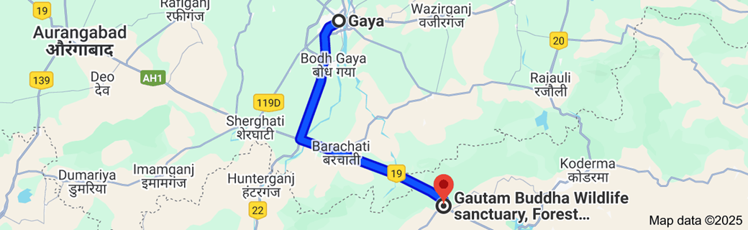

**Map 1: Route from Cāliya Hills to Gaya- distance 73.6 km [3]**

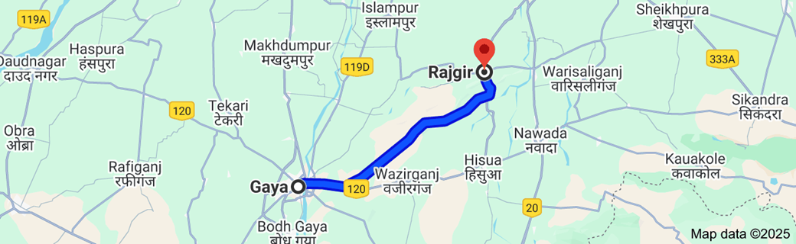

**Map 2: Route from Gaya to Rajgir - distance 60.8 km[4]**

## Significant Events Happened during that time

### Advice to Dhammika – The Duty of an Ascetic (AN 6:54)

While the Buddha was residing at Vulture Peak in Rājagaha, Venerable Dhammika arrived unexpectedly and paid his respects. When the Blessed One inquired about his sudden visit, Dhammika confessed that he had been expelled from seven monasteries due to his unwholesome conduct toward fellow monastics. Banished with nowhere else to turn, he had come seeking the Buddha’s guidance.

With great compassion, the Buddha shared a parable:

Once, King Koravya had a magnificent banyan tree that bore fruits as sweet as honey. Its five great branches provided for different groups—the royal family, officials, commoners, ascetics, and animals. Each took only what they needed, harming no part of the tree. However, an outsider greedily stripped the tree of its fruits and broke its branches. Disturbed by this, the tree deva, its guardian spirit, wished that the tree would stop bearing fruit—and so it did.

Concerned, King Koravya sought help from Sakka, the king of the devas. In response, Sakka conjured a storm and uprooted the tree. Devastated at losing his home, the tree deva lamented his fate. Sakka then advised him:

*"Had you practiced the duty of a tree—allowing all to take what they needed without resentment—this disaster would not have occurred."*

Realizing his mistake, the tree deva vowed to fulfill his duty, and through Sakka’s supernatural power, the tree was restored.

After sharing this story, the Buddha turned to Dhammika and asked:

*"Dhammika, have you been following the duty of an ascetic?"*

He then explained:

*"An ascetic does not insult one who insults him, does not scold one who scolds him, and does not argue with one who argues with him. This is how an ascetic fulfills his duty."*

The Buddha further emphasized this truth in verse:

*"One who harms a noble bhikkhu first harm himself, then harms the other. But one who protects himself also protects others. Therefore, the wise should safeguard themselves, remaining unshaken and unharmed."*

Through this profound teaching, the Buddha reminded Dhammika—and all practitioners—that true renunciation is not merely about external appearances but about inner restraint, patience, and unwavering equanimity.

### The Noble Qualities of an Arahant

In these discourses (AN 9:7 & 9:8), the two wanderers approached the Buddha with a profound inquiry regarding the nature of an arahant—the perfected one, free from all defilements. They sought to understand the incapability of an arahant to commit transgressions. The Buddha, in his boundless wisdom, confirmed:

*“A bhikkhu who is an arahant is incapable of transgression in nine ways.”*

An arahant, having completely eradicated the roots of greed, hatred, and delusion, is utterly incapable of engaging in the following:

1. **Taking life** – An arahant cannot intentionally deprive a living being of life.
2. **Stealing** – An arahant cannot take what is not given, by way of theft.
3. **Engaging in sexual intercourse** – Having fully transcended sensual desires, an arahant is incapable of such acts.
4. **Speaking falsehood** – Devoid of deceit, an arahant cannot deliberately utter falsehoods.
5. **Hoarding for sensual pleasure** – Having abandoned worldly attachments, an arahant does not accumulate possessions for personal enjoyment as he once did in lay life.
6. **Rejecting the Buddha** – An arahant has unshakable confidence in the Enlightened One.
7. **Rejecting the Dhamma** – An arahant never turns away from the liberating truth.
8. **Rejecting the Saṅgha** – An arahant remains firmly devoted to the community of noble disciples.
9. **Rejecting the training** – Having perfected the path, an arahant does not deviate from the noble discipline.

This teaching illuminates the supreme purity of an arahant—one who has transcended the realm of moral struggle and abides in the flawless peace of Nibbāna. The ninefold incapability is not a mere restraint but the natural expression of complete liberation. Just as a lotus remains untouched by the water in which it blooms, the arahant moves through the world yet remains untainted by its defilements.

### Dhamma Teachings to the wanderer Sakuludāyin

During his stay in Rājagaha, the Buddha, out of deep compassion, imparted many profound teachings to the wandering ascetics of other sects. Among these, two remarkable discourses in the *Majjhima Nikāya* were delivered to the wanderer Sakuludāyin. We have already explored the *Mahāsakuludāyi Sutta* (MN:77) in Section 7. Now, we turn to the second discourse, the *Cūḷasakuludāyi Sutta* (MN:79), which offers a teaching of immense depth and significance.

On one occasion in response to Sakuludāyin’s inquiry, the Blessed One declared:

*"It is not for the sake of realizing an exclusively pleasant world that bhikkhus lead the holy life under me. There are other states, Udāyin, higher and more sublime than that, and it is for the sake of realizing them that bhikkhus lead the holy life under me."*

With these words, the Buddha guided Sakuludāyin toward the essence of the Dhamma—the progressive refinement of the mind leading to the ultimate liberation, *Nibbāna.*

The Buddha explained how a bhikkhu in his dispensation attains these higher and more sublime states. First, he establishes unwavering faith in the Buddha and diligently cultivates wholesome qualities. Abandoning the five hindrances—the mental defilements that obscure wisdom—he enters into the profound states of meditative absorption (*jhāna*).

Having thus abandoned these five hindrances, imperfections of the mind that weaken wisdom, quite secluded from sensual pleasures, secluded from unwholesome states, a bhikkhu enters upon and abides in the first *jhāna*… up to the fourth *jhāna.* These are called higher and more sublime states, for the sake of realizing which bhikkhus lead the holy life under the Buddha.

Beyond deep meditative absorption, the bhikkhu further develops the threefold knowledge (*tevijjā*):

1. The recollection of past lives (*pubbenivāsānussatiñāṇa*).
2. The divine eye (*dibbacakkhu*), by which he perceives the arising and passing of beings according to their kamma.
3. The knowledge of the destruction of the taints (*āsavakkhayañāṇa*), through which he realizes the cessation of all suffering.

Upon seeing and knowing thus, his mind is liberated from the taint of sensual desire, from the taint of existence, and from the taint of ignorance. With this, the realization dawns:

**“Birth is destroyed, the holy life has been lived, what had to be done has been done, there is no more coming to any state of being.”**

Hearing this sublime teaching, Sakuludāyin was deeply moved. A seed of faith was planted within him, and he earnestly sought to go forth under the Buddha, renouncing the worldly life to pursue the path to liberation.

However, the weight of past kamma and the influence of his students prevented him from taking this noble step. They urged him to reconsider, saying:

*“Do not lead the holy life under the recluse Gotama, Master Udāyin. Having been a teacher, Master Udāyin, do not live as a pupil. For Master Udāyin to do so would be as if a water jug were to become a mere pitcher.”*

Thus, bound by attachments and entangled in worldly pride, he was obstructed from walking the path of deliverance. This is the sorrowful reality of unwholesome kamma—it can hinder even the most promising aspirations for spiritual growth.

Yet, the seed of the Dhamma, once planted, never truly perishes. Perhaps in another time, in another life, the wanderer Sakuludāyin would again encounter the path, and with wisdom, take the steps he was once denied.[5]

### The Spiritual Transformation of Venerable Pukkusāti

Pukkusāti, once the king of Takkasilā, became a seeker of truth after receiving a golden plate from King Bimbisāra, inscribed with praises of the Three Jewels. Deeply moved, he renounced his throne, donned the robes of an ascetic, and set out to meet the Buddha in Sāvatthī. [6]

Through his divine vision, the Buddha saw Pukkusāti’s potential for enlightenment and, out of boundless compassion, journeyed to meet him in a potter’s shed in Rājagaha. Concealing his extraordinary marks, the Blessed One appeared as a simple monk. That night, both sat in deep meditation.

When questioned about his teacher, Pukkusāti declared that he followed the recluse Gotama—unaware that the very Teacher he sought was before him. Seeing his readiness, the Buddha expounded the profound *Dhātuvibhanga Sutta* (MN:140), revealing the nature of existence through the six elements, six bases of contact, and the eighteen ways the mind explores experience. He taught that one who transcends these, standing firmly on the four foundations—wisdom, truth, relinquishment, and peace—becomes a *sage at peace,* beyond the tides of conceiving.

Upon hearing this sublime discourse, realization dawned upon Pukkusāti: *"Indeed, the Teacher has come to me!"* Overcome with reverence, he prostrated at the Buddha’s feet, filled with faith and joy. Wishing to formally ordain, he left to seek a bowl and robes. Yet, before he could return, fate intervened—a stray cow took his life.

When asked of his destiny, the Buddha declared:

*"With the destruction of the five lower fetters, Pukkusāti has been reborn in the Pure Abodes. There, he will attain final Nibbāna, never to return to this world."*

Thus, though his time in the human realm was brief, Pukkusāti’s unwavering faith, wisdom, and practice led him to the highest path. His journey reminds us that the Dhamma, once realized, transcends even death, guiding beings toward the ultimate liberation.[7]

## Brief Yet Profound Discourses of the Buddha

While residing in Rājagaha, the Blessed One delivered several brief yet deeply insightful teachings, illuminating the nature of life and the path to liberation.

The Fleeting Nature of Life (SN 4:9 & 10)

The Buddha reminded the bhikkhus of the fleeting nature of human existence:

*“Bhikkhus, the life span of human beings is short. One must inevitably move on to the next existence. Therefore, one should cultivate wholesome deeds and lead the holy life. For one who has taken birth, there is no escape from death. Even one who lives long may reach but a hundred years—or a little more.”*

Reflecting on this, the Buddha offered a stirring verse:

Short is the life span of human beings,  
The wise should not be heedless.  
One should live as if one’s head were aflame,  
For death is certain and cannot be avoided.

Like water dwindling in a drying stream, each moment brings us closer to the end of life. Recognizing this truth, the Buddha urged:

*“Life is swept away; short is the life span.  
There is no refuge for one who has grown old.  
Seeing this danger in death,  
A seeker of peace should abandon the world’s bait.”* *(SN 2:19)*

These words awaken urgency in the heart, reminding us to use our fleeting time wisely, striving for what truly matters.

The Killing Praised by the Noble Ones (SN 7:1)

Once, a young brahmin asked the Buddha whether he ever approved of killing. In response, the Buddha offered a profound teaching:

*“Having slain anger, one sleeps soundly;  
Having slain anger, one sorrows no more.  
Anger, with its poisoned root and honeyed tip—  
This is what the noble ones praise killing,  
For having slain this, one grieves no more.”*

Unlike the destruction of life, the destruction of anger leads to peace. Anger, though often enticing at first—like honey on the tongue—ultimately poisons the heart. True victory lies not in harming others but in conquering one’s own defilements.

Through these brief yet powerful discourses, the Buddha urges us to awaken, to see the fragility of life, and to abandon the poisons that keep us bound to suffering.

### Venerable Ānanda: The Humble and Devoted Attendant of the Buddha

For the first twenty years of his ministry, the Blessed One had no permanent attendant. Various bhikkhus—such as Venerables Cunda, Meghiya, Nāgasamāla, and Upavāna—served him at different times. However, as the Buddha grew older, residing in Rājagaha, he addressed the Sangha:

*“Bhikkhus, I have grown old now. It is time to have a bhikkhu as my constant attendant.”*

Upon hearing this, Venerable Sāriputta, renowned for his wisdom, respectfully offered to take on the role. However, the Buddha, ever mindful of each disciple’s unique qualities, declined, saying:

*“Sāriputta, wherever you are, there is the Dhamma. Your duty is to teach as I do. You should not serve as my attendant.”*

One by one, other great disciples also offered themselves, but the Buddha declined them all.

Amidst the gathering, Venerable Ānanda remained silent. Seeing this, the bhikkhus urged him to step forward, but he humbly replied:

*“Friends, this position is not something to be sought. If the Buddha wishes it, he will call upon me.”*

The Buddha, perceiving Ānanda’s sincerity and devotion, then declared:

*“Bhikkhus, Ānanda does not need to be asked—he will serve out of his own free will.”*

Thus, Venerable Ānanda, with deep humility and boundless love, became the Blessed One’s devoted attendant.

#### A Life of Service and Loving Devotion

For twenty-five years, Venerable Ānanda served the Buddha with unwavering care, ensuring his every need was met. He was always available to assist the Sangha and lay disciples, offering guidance with a kind and patient heart. His remarkable memory preserved countless teachings, and his eloquence brought inspiration to all who listened.

The Buddha praised him in many ways, declaring:

*“Bhikkhus, among those who are learned, Ānanda is foremost. Among those with a good memory, Ānanda is foremost. Among those with a quick grasp, Ānanda is foremost. Among those who are resolute, Ānanda is foremost. Among personal attendants, Ānanda is foremost.”* (AN 1:209)

His presence was a source of joy and inspiration for all:

*“When bhikkhus, bhikkhunīs, male lay followers, or female lay followers see Ānanda, they are elated. When he speaks, they are uplifted. Even when he falls silent, they are never satisfied, wishing to hear more.”* (AN 4:129)

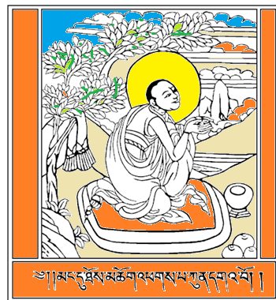

Venerable Ānanda: Tibetan Illustration [8]

In his own words, Venerable Ānanda reflected on his years of service:

“For twenty-five years,  
I attended the Blessed One  
With loving deeds,  
Like a shadow that never left.

For twenty-five years,

I attended the Blessed One  
With loving words,  
Like a shadow that never left.

For twenty-five years,  
I attended the Blessed One  
With loving thoughts,  
Like a shadow that never left.” (Thag 1044–1046)

Venerable Ānanda embodied the noble qualities of humility, devotion, and selfless service. His unwavering dedication ensured that the teachings of the Buddha were preserved for future generations, a legacy of compassion and wisdom that continues to guide seekers of the Dhamma.

With this inspiring account of Venerable Ānanda, we conclude this section. In the next section (Section 18), we will explore the other rainy season abodes where the Blessed One resided.

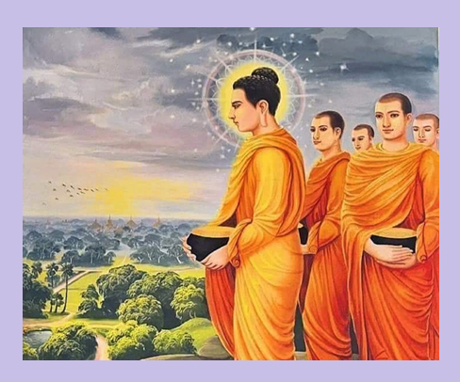

**The Buddha and Venerable Ãnanda with other disciples [9]**

### End Notes: Section 17

1. Source 1: Madhuratthavilāsinī (Buddhavaṁsatthakathā) of Bhadantâcariya Buddhadatta Mahathera: Translated by I. B. Honer, 1946.
2. Source 2: Jinacaritaṁ, The Life of the Victorious Buddha, translated by Bhikkhu Anandajoti.
3. Google map.
4. Ibid.
5. MA explains that in a previous life, as a monk during the time of the Buddha Kassapa, he had

   persuaded another monk to return to lay life in order to gain his robes and bowl, and this obstructive

   kamma prevented him from going forth under the Buddha in this life. But the Buddha taught him two long suttas to provide him with a condition for future attainment. During the reign of King Asoka he attained arahantship as the Elder Assagutta, who excelled in the practice of loving-kindness, see: MN: Note: 786.
6. MN:140
7. MA says that he was reborn in the Pure Abode called Avihā and attained arahantship as soon as he

   took rebirth there. It quotes a verse from the Saṁyutta Nikāya (SN 1:50/i.35) mentioning Pukkusāti as one of seven bhikkhus who were reborn in Avihā and attained deliverance by transcending the celestial bonds, see: MN: Note: 1287.
8. Source: <https://encyclopediaofbuddhism.org/wiki/%C4%80nanda>
9. Source: <https://www.instagram.com/gautama_buddha_shakyamuni/p/CsNIEniotEW/>